ORDER OF WORSHIP
* Indicates, please stand if able.
Second Sunday of Advent December 10, 2023, 9 am
Liturgist: Katrina McGillivray

WELCOME, PASSING THE PEACE OF CHRIST, & ANNOUNCEMENTS
*CALL TO WORSHIP (Psalm 85, 2 Peter 3, Mark 1)
L: Prepare the path of God.
P: We prepare by waiting with patience.
L: Prepare the path of God.
P: We prepare by living with faith and love.
L: Prepare the path of God.
P: We prepare by pursuing justice and peace.
L: Prepare the path of God.
P: We prepare, we wait, we pray.
L: May God bless us with both patience and passion.
P: We wait and pray to create the path of God.
LIGHTING OF ADVENT CANDLE #1: Dylan Dutton, Darrin & Anne Boehm
Reader 1: In days when God’s people longed for peace, Isaiah declared, “Comfort, O comfort my people, says your God. Speak tenderly to Jerusalem, and cry to her that she has served her term, that her penalty is paid, that she has received from the Lord's hand double for all her sins” (Isaiah 40:1).
Reader 2: We who gather today also seek comfort and peace, yet we are unsatisfied with ideas of peace that tell us to keep quiet and go with the flow. We long for real peace, true peace, just peace.
Congregation: We wait as people who yearn for peace that bears the fruit of community, equity, and flourishing for all.
Reader 1: We light these candles as signs of God’s shocking hope and just peace. May they be beacons calling us to repent and to live the good news of Jesus Christ as we wait and watch and labor for the day when all people can gather together to worship and glorify God. Amen.
CONGREGATION: “Come, O Come, Emmanuel” (v.2) UMH #211
*OPENING PRAYER (Psalm 85, 2 Peter 3, Mark 1)
While we are waiting, come to us, O God. Reveal your presence in our time of worship. Guide our steps in our speaking and our doing. Flow through our lives, our church, and our world with your steadfast love, unending faithfulness, righteous justice, and mysterious peace. In patient anticipation, we pray. Amen.

*OPENING HYMN People, Look East UMH #202
CHILDREN'S TIME Roxie Hostrawser
JOYS AND CONCERNS

PRAYER OF CONFESSION
Into the dark depths of our fear and anguish, you, O Lord, reach out to us. We need your guidance this day, for we have found it far too easy to stray into selfish pathways. We seek first our own comfort; we gather our toys and trinkets and proclaim that all is right with the world, yet our hearts feel strangely discomforted. Guide us and gather us, Lord. Teach us again to be people of peace and hope. Help us to cast off the mantle of greed and hatred. Forgive us for the many times when we have ignored the cries of those in need; when we have turned our backs on opportunities to help others. Forgive us, Lord. Touch our hearts and bring your bright light of salvation to them that we might turn again to you and in your love may be part of ministries of peace and justice. Help us again to hear the voice of one who cries in the wilderness, “Prepare the way of the Lord. Make straight in the desert a highway for our God.” In the name of Jesus Christ, our Savior, we offer this prayer. AMEN.
WORDS OF ASSURANCE (Ephesians 1)
God’s forgiving love has been poured upon each one of us. Hear the good news! You are healed and forgiven! AMEN.
PASTORAL PRAYER Rev. Shon
THE LORD’S PRAYER (In Unison)
INVITATION TO THE OFFERING
*DOXOLOGY Praise God, from Whom All Blessings Flow UMH #94
*OFFERTORY PRAYER Rev. Shon
SCRIPTURE Mark 1:4-8
⁴ And so John the Baptist appeared in the wilderness, preaching a baptism of repentance for the forgiveness of sins. ⁵ The whole Judean countryside and all the people of Jerusalem went out to him. Confessing their sins, they were baptized by him in the Jordan River. ⁶ John wore clothing made of camel’s hair, with a leather belt around his waist, and he ate locusts and wild honey.⁷ And this was his message: “After me comes the one more powerful than I, the straps of whose sandals I am not worthy to stoop down and untie. ⁸ I baptize you with water, but he will baptize you with the Holy Spirit.”
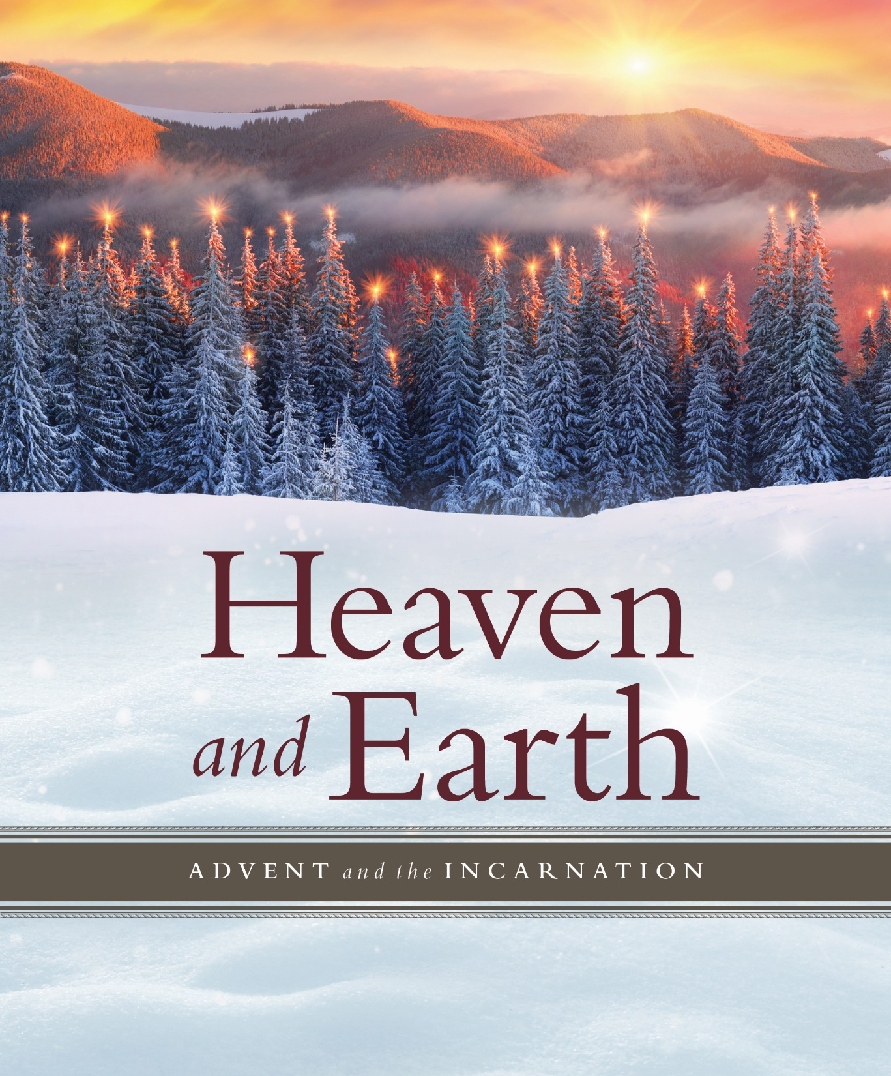
*HYMN OF PRAISE Wild and Lone the Prophet’s Voice TFWS #2089
SERMON Surprised Rev. Shon
*CLOSING HYMN To a Maid Engaged to Joseph UMH #215
*BENEDICTION Rev. Shon

ANNOUNCEMENTS
PRAYER REQUESTS: Please pray for people in need in our church, community, nation,
and the World.
STEWARDSHIP CAMPAIGN: for the upgrade of the sound and video system at the
Sanctuary, boilers replacement, and next year’s church budget.
CHURCH CONFERENCE: Today at 3 pm
WEDNESDAY CONNECTIONS: Meal served by Gil Homstad/Judy Hansen at 5:00 pm
DINNER CHURCH INITIATIVE: Wednesday, Dec. 13th, 5 pm.
WANTED: Team members for Dinner Church
SCRIP CARDS: Today is the last day to place an order for Scrip cards for Christmas that
are not on hand. To order, stop in the gathering area or call Marcia at 715-284-3346.
USHER/GREETERS: Dave & Sherry Olson
FELLOWSHIP: Judy Shepard

UPCOMING MEETINGS

Sun Dec. 10 Church Conference 3:00 pm
Wed Dec. 13 Dinner Church Ministry 5:00 pm
Sun Dec. 24 Christmas Eve Candlelight Service 5:00 pm

BLACK RIVER FALLS
UNITED METHODIST CHURCH

UMC Mission Statement:
"To make disciples of Jesus Christ for the transformation of the world.”

PASTOR Rev. Inwha Shon
PIANIST Joyce Moldenhauer

100 North Fourth Street, Black River Falls, WI. 54615
Phone: 715-284-4114 Office Hours: Monday-Thursday, 9 am-2 pm
Website: brfumc.org YouTube: brfumc
Facebook: Black River Falls United Methodist Church

